Proyecto de Español 7A & 7B
*you can work by yourself or with a partner and will create a magazine store.
* You must include your name(s), period, name of the store at the front page.
* You will model clothes and accessories from Capitulo 7A & 7B (342 & 370).
* You must include clothes for women & men. (You can ask a friend or family member permission to model for your pictures in case you don’t have the other gender in your group). *No internet pictures
* You must have between 20-25 clothing items and between 10-15 pictures (1 picture per page). You can label only 2 words per picture.
* Don’t include traje de baño.
* -You must label every picture in Spanish (don’t repeat items).
-Write the Price with number and letters with the word Cuesta(n):. All prices must be different. Price must be more than 100 pesos (1 dollar=20 pesos)
-Write the colors that you offer every item. Colores:
-Include Talla (size): Pequeña, mediana, grande, Extra pequeña, extra grande. (Only the sizes that you want for your items).
*Check your spelling and remember this is a project grade. Make it clean and with appropriate pictures.

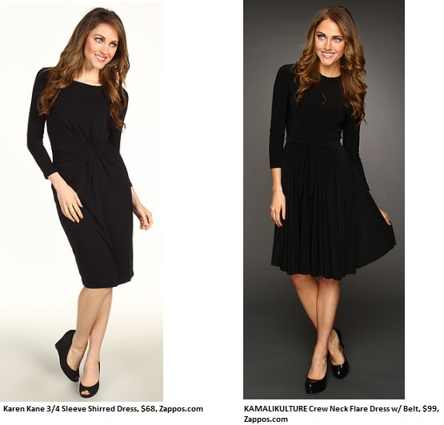

Cuesta: quinientos pesos ($500)
Colores: negro y blanco
Talla: mediana y grande
Vestido

